**Requirements**.

A database implementation suitable for access by contributors and information consumers. Consider using Maritime Connectivity Platform as a means to discover the service:

* A Graphical User Interface (GUI) that permit the source originators, such as harbour masters, to easily input and validate information, in a secure mode, while also allowing authorised hydrographic offices to review and extract needed information suitable for their products which are to be made available to end-users, the mariners. – needs use cases, example data. **Agree – this is contained in the detailed architecture diagram**
* Create an Application Programming Interface (API) to simplify and expedite the information flow between harbours that have a GIS system in place and authorised hydrographic offices by connecting their GIS systems and extract information. The API should be based on open API standards, for example, OGC API Features (open source). – in design. **Partly Agree. Data export via API (specifically OGC API Features) is easy to achieve. Data input may need to be through flat file (bulk) transfer as well as API (and should ENC be supported to (at least partly) input base S-131 features. Difficulty is mapping input formats to S-100 GFM attribution. Any user input will need to be mediated by the GUI as well. We believe this detail can be worked out as we explore use cases for data input.**
* Documentation which include details about the management and configuration of the database, GUI and API sufficient for database operator – **Agree**
* Documentation for all system users and administrators - **Agree**
* Definitions of data elements need to be updateable to match with ongoing work between IHO, IHMA and IMO-FAL. - use S-100GFM db backend **Agree, database is S-100 and will be updateable via S-131 FC.**
* *Identity management to ensure information can only be accessed as per source provider requirements. Consider using the Maritime Connectivity Platform identity register as means of accomplish this.* **Needs to be explored. This should be ok but should also consider S-100 identity management (Part 15) which is interoperable with MCP. Who is the authority (SA)? The intention is not to build a complex identity management system so users may have to e.g. register with IHO before using the system and have a certificated identity authorized by IHO?**
* Put together a beta database of a fictive port (in Useland) to try out the S-131 data structure and be able to picture it. – *testing* **Agree, testing will implement this.**
* I suggest you expand these tasks into smaller tasks or milestones if needed and try to build a 2 years timeline and decide among NTOU and IIC who has the best expertise to do each task. I can assist in that if needed.**in description, next section.**
* Consider the table on next page if needed as a general timeline reference, from the project application. **In timelines, next section.**

**Architecture notes.**

Combined diagram of all layers is shown below. We believe there are four major components.

1. User / GUI tier
2. API middleware
3. Backend
4. Data outputs

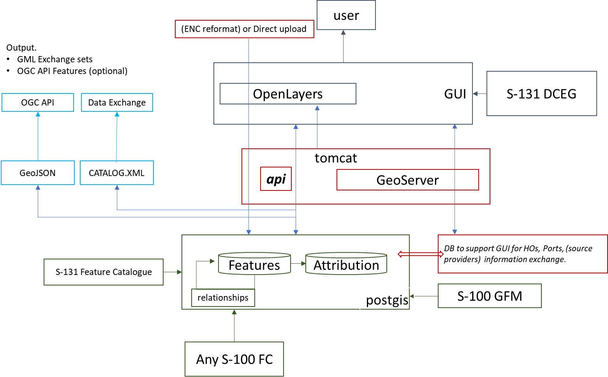

**Front end GUI (NTOU)**

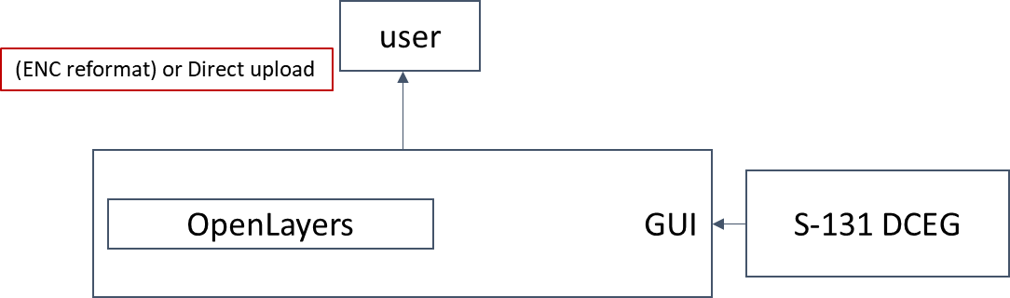

This layer provides a rich GUI which allows:

1. Users to digitise geometry
2. Encoding of semantic content in conformance with S-131 FC
3. User upload of existing data in (to be determined) formats
4. Other GUI functions – user management / authentication and access to tools such as validation

**Backend (IIC)**

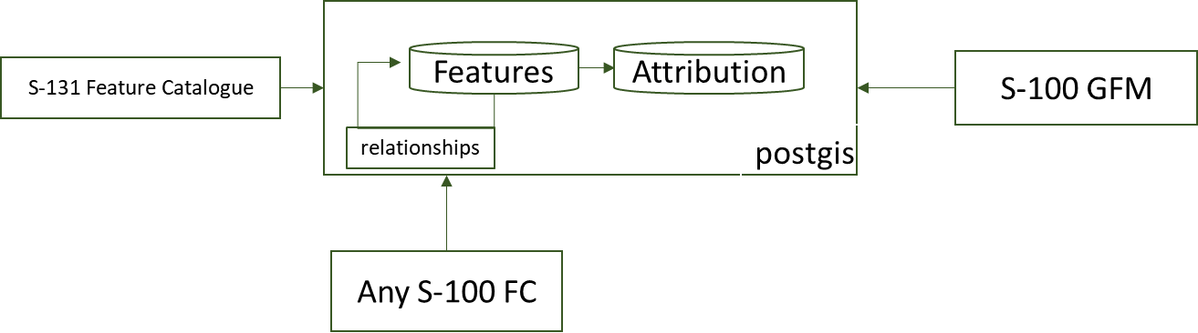

* Back end database is PostgreSQL/PostGIS
* Database is S-100 level so product neutral with open schema
* Schema has tables for geometry, features, attribution and relationships
* The S-131 feature catalogue moderates the content in the database.
* Library functions mediate all access to the database and retrieve features/geometry in S-100 GFM form.

**Backend (NTOU)**

Supporting database (will need adaptation in the API for i/o and GUI integration).

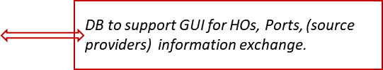

Data collections

* Base (World) map
* Ports
* UN LOCODE
* SMDG Code
* Port Facility number (IMO GSIS)
* UB5/UB6 ENC Coverage

**Middleware (Platform NTOU, API IIC, will need collaboration on API definition)**

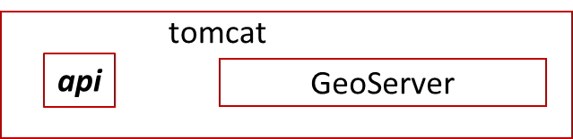

The middleware component is a set of webapps hosted on a tomcat server, including GeoServer. An API component enables REST access to the database backend for upload and retrieval of S-131 content. The API has a swagger interface for documentation and testing.

Geoserver is used to retrieve geometry from the database via web services.

**Data Export (IIC)**

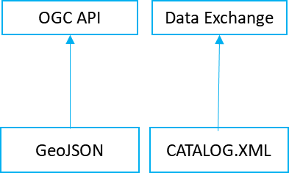

Data exports are performed from the database (using middleware components where required and controlled from the User front end). The outputs are OGC API endpoints (hosted using pygeoapi) and exchange in GML (or ISO8211) form via flat file download. These can be activated via user GUI, library functions will be between the database and middleware components (possibly part of the API).

**Timelines**.

Suggest the following sequence of items in the development. The dataflow/API and DB implementation can (initially) progress in parallel with development of use cases (data input, data output and GUI elements). As the DB/API is maturing the GUI can be designed and, through a number of sprints implemented. As the system matures integration of the two main elements is executed while comprehensive reference test data is prepared. We suggest a collaborative environment, using open source hosting tools (GitHub) for code management, issue tracking and releases.

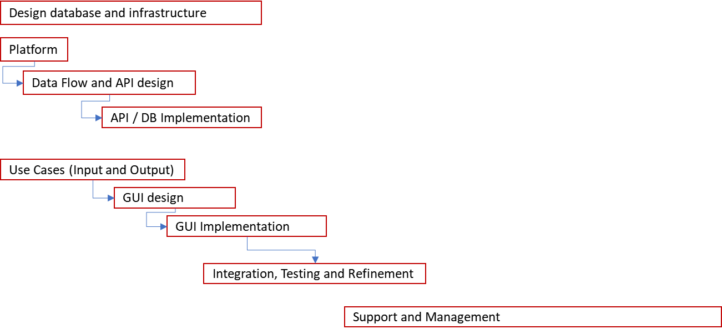

Timelines are TBD. Overall those in the original diagram would seem to be achievable but use case exercises need to be done to establish levels of functionality required.

S-131 feature catalogue is a fairly major dependency but initial development can progress with a draft catalogue. Testing will need to encompass FC updates and data migration.